Financial Behavior Engine

NetSuite Costing Engine Architecture
Inventory Costing Methods and Financial Impact
Weekly Learning Series – Week 4

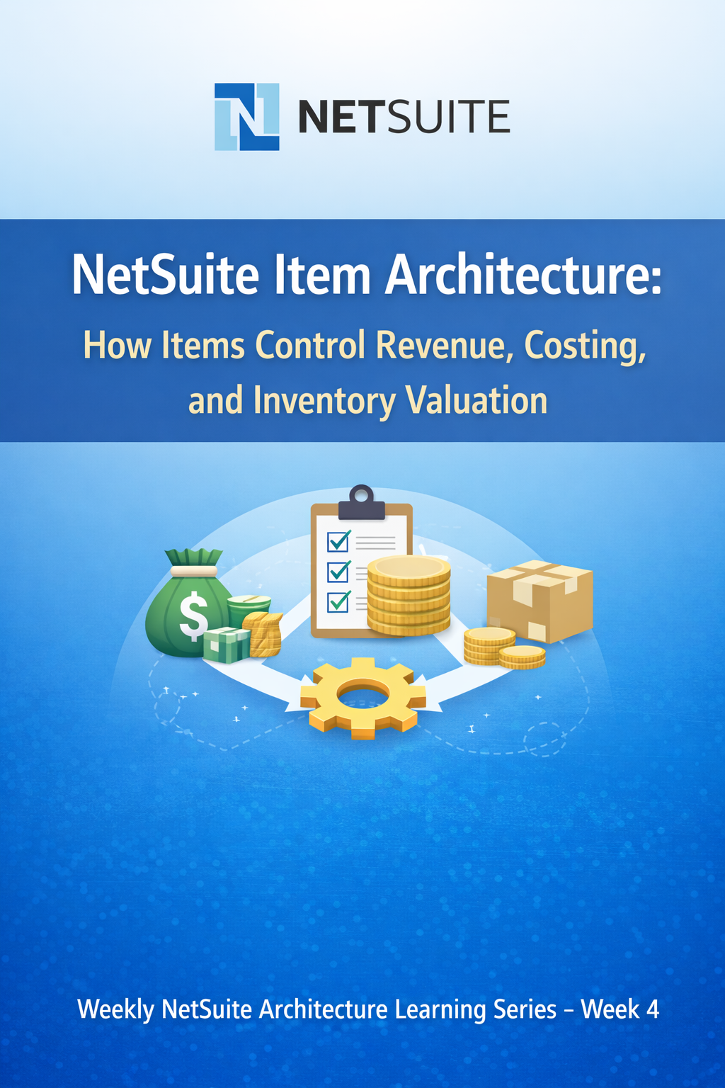

Costing Engine
- The Costing Engine in NetSuite determines how inventory costs are calculated, stored, and relieved during inventory transactions.
- The costing method defined on an Item record controls how the system determines the cost associated with inventory movements such as receipts, transfers, and sales.
- Costing methods influence several important financial outcomes, including:
  - When Cost of Goods Sold (COGS) is recognized
  - How inventory is valued on the Balance Sheet
  - How gross margins fluctuate across reporting periods
  - How inventory costs are assigned when items are sold or consumed
  - How inventory valuation aligns with the organization's accounting policies
- Because of these impacts, the costing method is not merely an operational configuration.
- The costing method represents an accounting policy applied to inventory items, and it directly affects:
  - Inventory valuation
  - Cost of Goods Sold
  - Profitability reporting
  - Financial statement accuracy
  - Audit traceability
- For this reason, the costing method should be selected carefully during system implementation and typically remains unchanged after transactions begin.

Inventory Cost Flow Model
- The costing method determines which inventory cost is relieved when items are sold or consumed.
- When inventory is received, NetSuite records the cost associated with that receipt.
When inventory is sold or otherwise removed from stock, the system uses the selected costing method to determine which recorded cost should be applied to the transaction.
- Depending on the costing method, NetSuite may:
  - Track individual cost layers
  - Maintain a running average cost
  - Use a predefined standard cost
  - Track cost at the lot or serial number level
- The selected costing method therefore defines the inventory cost flow model used by the system.
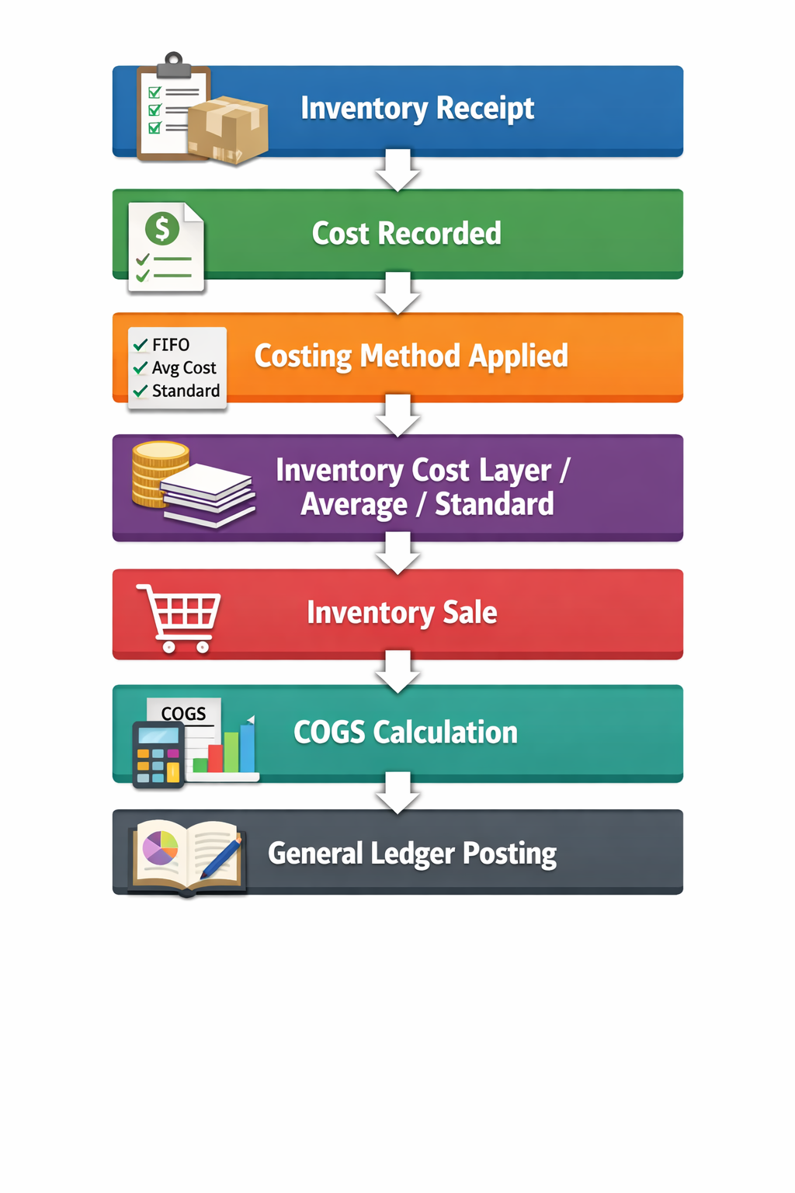

  - Costing Methods Supported in NetSuite
- NetSuite supports several inventory costing methods that determine how inventory cost is assigned when items are sold or consumed:
  - FIFO (First-In, First-Out)
  - LIFO (Last-In, First-Out) – Region dependent
  - Average Cost
  - Standard Cost
  - Specific Identification (used with Lot Numbered or Serial Numbered inventory items)
- Each method affects:
  - How Cost of Goods Sold (COGS) amounts are calculated
  - How inventory costs are stored and applied
  - Gross margin volatility
  - Audit complexity & traceability
  - Financial comparability across periods
- Selecting the appropriate costing method requires alignment between operational processes and financial reporting policies.

Costing Method | Cost Layer Tracking | Margin Volatility | Complexity
FIFO | Yes | Medium | Medium
LIFO | Yes | Medium | High
Average | No | Low | Low
Standard | No | Very Low | High
Specific Identification | Per Unit / Lot | Variable | Very High

4.2 FIFO – First In, First Out
- FIFO (First-In, First-Out) is an inventory costing method in which the oldest inventory cost is applied first when items are sold or consumed.
- When inventory is received, NetSuite records the cost associated with that receipt and creates a cost layer.
- When inventory leaves stock, the system relieves cost from the earliest available cost layer

Business Use Case
- FIFO is commonly used in industries where inventory tends to move in the same order in which it was received
- Typical examples include:
  - Retail organisations
  - Distribution businesses
  - Manufacturing environments with predictable inventory flow
  - Businesses where physical inventory flow approximates chronological receipt order

Example
Inventory Purchases:
Receipt | Quantity | Cost
Purchase 1 | 10 | 100
Purchase 2 | 10 | 120

Total Inventory: 20 units
Total value = 2200
Inventory Sale: Sell 15 units
COGS Calculation under FIFO: (10 × 100) + (5 × 120) = 1600
Remaining Inventory: 5 units @ 120 = 600
The remaining inventory reflects the most recent purchase cost.

Financial Impact
- FIFO affects financial reporting in several ways.
  - Cost of Goods Sold (COGS) reflects older inventory costs
  - Ending inventory valuation reflects more recent purchase costs
  - During periods of rising prices (inflation)
  - COGS tends to be lower
  - Gross margins appear higher
    - During periods of falling prices (deflation)
    - COGS tends to be higher
- Gross margins appear lower
- Because of this behaviour, FIFO often produces inventory values that are closer to current market costs.

NetSuite-Specific Considerations
- In NetSuite, FIFO costing operates using inventory cost layers that are created whenever inventory is received.
- Key system behaviours include:
  - Each inventory receipt creates a new cost layer
  - Inventory issues (sales, adjustments, builds) consume cost from the oldest available layer first
  - Backdated transactions can cause NetSuite to recalculate historical cost layers
  - Inventory adjustments may alter cost layer balances
  - High-volume environments can create large numbers of cost layers, which may affect costing recalculation time
- Because FIFO relies on chronological cost layers, organizations should maintain strong controls around:
  - Backdated inventory transactions
  - Accounting period locking
  - Inventory reconciliation procedures
- Proper controls help prevent unexpected costing recalculations and historical margin changes.

4.3 LIFO – Last In, First Out
Definition
- LIFO (Last-In, First-Out) is an inventory costing method in which the most recently acquired inventory cost is applied first when items are sold or consumed.
- Similar to FIFO, inventory receipts create cost layers.
However, when inventory leaves stock, NetSuite applies cost from the newest available cost layer first
Business Use Case
- LIFO is sometimes used in environments where inventory costs are rising rapidly.
- Typical scenarios include:
  - Inflation-heavy economic environments
  - Organizations seeking tax advantages from higher reported COGS
  - Jurisdictions where LIFO is permitted under local accounting standards
- Because LIFO increases reported cost during inflation, it can reduce taxable income in certain region

Example
Inventory Purchases:
Receipt | Quantity | Cost
Purchase 1 | 10 | 100
Purchase 2 | 10 | 120

Total Inventory: 20 units
Total value = 2200
Inventory Sale: Sell 15 units
COGS Calculation under LIFO: (10 × 120) + (5 × 100) = 1700
Remaining Inventory: 5 units @ 100 = 500
The remaining inventory reflects the older purchase cost.

Financial Impact
- LIFO influences financial reporting differently from FIFO.
  - Cost of Goods Sold (COGS) reflects newer inventory costs
  - Ending inventory valuation reflects older inventory costs
  - During inflation, COGS tends to increase
  - Higher COGS results in lower reported profit
  - Lower profit may reduce tax liability in certain jurisdictions
- However, because older inventory costs remain on the balance sheet, inventory valuation may become less representative of current market prices

Important NetSuite Note
- LIFO is not universally available in all countries and depends on accounting preferences and regulatory requirements
- Many organizations do not use LIFO because it is not permitted under IFRS accounting standards
- LIFO increases audit complexity due to cost layer tracking and tax implications
- For these reasons, LIFO is less commonly implemented in modern ERP environments.

4.4 Average Cost
Definition
- Average Cost is an inventory costing method in which NetSuite maintains a running average cost for each item.
- When inventory is received, the system recalculates the average cost based on the total inventory value and total quantity on hand.
- Inventory issues such as sales, transfers, or adjustments then use the current average cost to calculate Cost of Goods Sold (COGS).
- Unlike FIFO or LIFO, Average Cost does not track individual cost layers.
Cost Calculation Formula
- When new inventory is received, NetSuite recalculates the average cost using the following principle:
- Average Cost = Total Inventory Value / Total Quantity On Hand
- After a new receipt, the inventory value and quantity are updated, producing a new weighted average cost.

Example
Inventory Purchases:
Transaction | Quantity | Cost
Purchase 1 | 10 | 100
Purchase 2 | 10 | 120

Total Inventory Value: 1000 + 1200 = 2200
Total Quantity: 20 units
Average Cost: 2200 / 20 = 110
Inventory Sale: Sell 15 units
COGS Calculation: 15 × 110 = 1650
Remaining Inventory: 5 × 110 = 550
All remaining units carry the same average cost.

Financial Impact
- Average costing influences financial reporting in several ways.
  - Gross margin volatility is reduced because cost fluctuations are averaged over time
  - Inventory valuation reflects a blended cost of recent purchases
  - Profit margins tend to change gradually rather than sharply
  - The method is often easier for operational teams to understand and manage
- However, because individual purchase costs are not preserved, Average Cost provides less traceability than layer-based costing methods.

NetSuite-Specific Risks
- In NetSuite, average cost is maintained separately for each item and location.
- Key behaviours include:
  - Average cost is recalculated when inventory is received
  - Inventory issues use the current average cost at the time of the transaction
  - Backdated inventory receipts can trigger recalculation of historical average costs
  - Inventory adjustments that affect quantity or value may change the future cost basis
  - Because individual purchase layers are not tracked, average costing provides less audit traceability than FIFO or Specific Identification
- For this reason, organizations using average costing should maintain strong controls over:
  - Backdated inventory transactions
  - Inventory adjustments
  - Period closing procedures
- Average costing prioritizes operational simplicity and margin stability over detailed cost traceability.

Average Cost Recalculation Behaviour in NetSuite
- NetSuite recalculates the average cost when inventory receipts are entered.
However, when a receipt is backdated, the system may recalculate the average cost for historical periods.
- This occurs because the newly entered transaction changes the inventory value and quantity that existed at that earlier point in time.
- When this happens, NetSuite may update the cost basis used for transactions that occurred after the backdated receipt.
Example Scenario
- Inventory Receipt – January 1
10 units @ 100
Average Cost = 100
- Sale – January 10
5 units sold
COGS = 5 × 100 = 500
- Backdated Receipt entered later – January 5
10 units @ 120
- When the new receipt is inserted into the historical timeline, NetSuite recalculates the average cost as if the transaction had existed on January 5.
- The revised inventory history becomes:
  - Jan 1 → 10 units @ 100
  - Jan 5 → +10 units @ 120
  - New Average Cost = 110
- As a result, the sale on January 10 may be recalculated using the updated average cost:
  - 5 × 110 = 550 COGS
- This adjustment changes the historical margin and inventory valuation for that transaction.

Operational Implications
- Because average costing can recalculate historical values, organizations should implement strong operational controls, including:
  - Restricting backdated inventory transactions
  - Locking accounting periods once financial reporting is finalized
  - Reviewing inventory costing reports after adjustments
  - Monitoring cost changes during month-end close
- Without these controls, historical margins and inventory values may change unexpectedly after late inventory entries.

4.5 Standard Cost
Definition
- Standard Cost is an inventory costing method in which a predefined cost is assigned to an item based on expected production or procurement costs.
- The standard cost is typically determined by Finance or Cost Accounting teams using planned cost estimates such as:
  - material cost
  - labour cost
  - overhead allocation
- In NetSuite, inventory is always valued using the standard cost defined on the item record.
- When the actual transaction cost differs from the standard cost, the difference is recorded in variance accounts rather than adjusting inventory valuation.

Common Variance Types
- Standard costing generates several types of cost variances that help organizations monitor cost performance.
- Common variance categories include:
      - Purchase Price Variance (PPV) – difference between actual purchase price and standard cost
      - Production Variance – difference between expected and actual production costs
      - Usage Variance – difference between planned and actual material consumption
      - Scrap Variance – variance caused by material waste or scrap during production
      - Rate Variance – difference between expected and actual labour or machine rates
- These variances allow organizations to analyse operational efficiency and cost control.

Example
Standard Cost: 100
Purchase Transaction: 10 units purchased @ 120
Inventory Valuation: 10 × 100 = 1000
Actual Purchase Cost: 10 × 120 = 1200
Variance: (120 – 100) × 10 = 200
Accounting Entry:
- Dr Inventory Asset 1000
- Dr Purchase Price Variance 200
- Cr Accounts Payable 1200
Inventory remains valued at standard cost, while the difference is recorded in a variance account.

Financial Impact
- Standard costing affects financial reporting in several ways.
  - Gross margins remain stable, because inventory cost does not fluctuate with purchase price changes
  - Variance accounts provide visibility into operational cost differences
  - Financial statements separate planned costs from operational inefficiencies
  - The method is commonly used in manufacturing environments with structured cost models
- However, variance accounts must be monitored carefully to ensure that cost differences are properly analysed.

NetSuite-Specific Considerations
- In NetSuite, standard costing introduces additional operational processes.
- Key considerations include:
  - Standard cost values must be defined and maintained on item records
  - Assembly items require cost rollups to calculate the standard cost from component costs
  - Variances may occur during transactions such as item receipts and work order completions
  - Changes to standard cost require an inventory revaluation process to update inventory value
- Because inventory valuation remains fixed at the standard cost, variance accounts may accumulate if they are not reviewed regularly.
- Organizations using standard costing should implement strong governance procedures, including:
  - periodic cost rollup reviews
  - monitoring variance accounts
  - controlled processes for updating standard costs
- Standard costing provides predictable financial reporting, but it requires disciplined cost management practices.

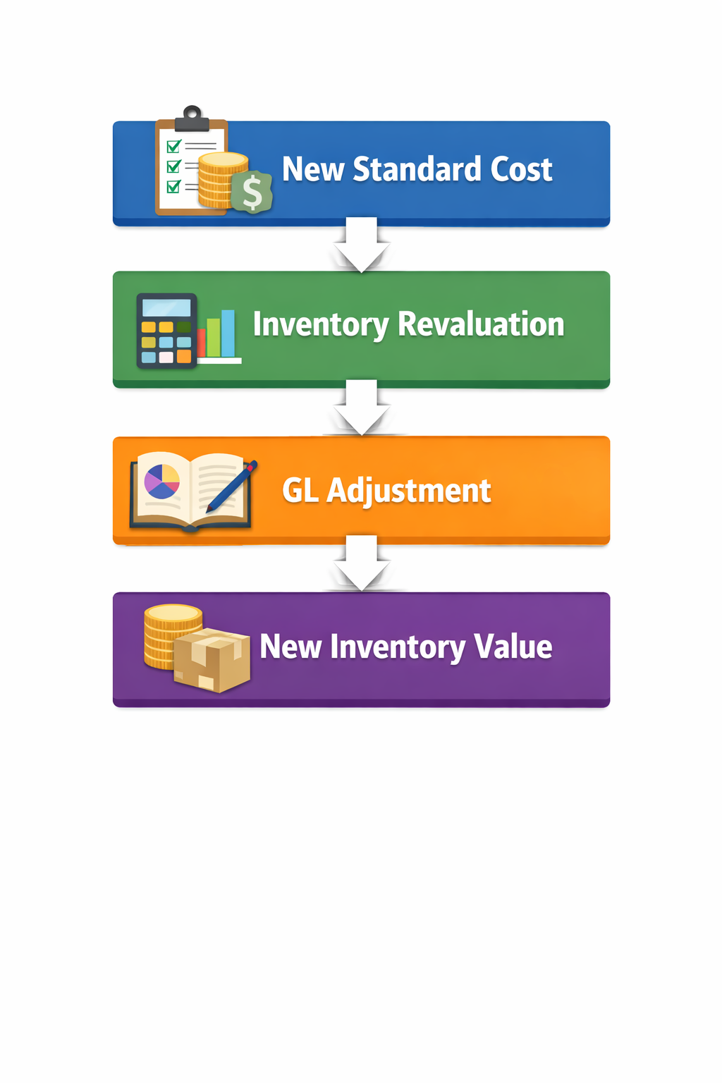

4.6 Specific Identification (Lot / Serial-Based Costing)
Definition
- Specific Identification is an inventory costing method in which each individual inventory unit retains its own cost value.
- Instead of applying cost based on cost layers or averages, NetSuite assigns cost based on the exact lot or serial number that is sold or consumed.
- When an item is issued from inventory, the system uses the specific cost associated with the selected lot or serial number to calculate Cost of Goods Sold (COGS).
- This method therefore provides unit-level cost tracking.

Business Use Case
- Specific Identification is commonly used in industries where:
  - Individual items must be uniquely tracked
  - Product traceability is required for regulatory compliance
  - Inventory units have significantly different costs
- Typical examples include:
  - Pharmaceuticals and medical devices
  - High-value electronics
  - Automotive components and aerospace parts
  - Luxury goods and high-value retail items
  - Regulated industries requiring lot traceability

Example
Inventory Receipts:
Lot / Serial | Quantity | Cost
Lot A | 10 | 100
Lot B | 10 | 120

Inventory Sale: Sell 5 units from Lot B
COGS Calculation: 5 × 120 = 600
Remaining Inventory:
Lot A → 10 units @ 100
Lot B → 5 units @ 120
Each lot retains its original purchase cost.

Financial Impact
- Specific Identification affects financial reporting in several ways.
  - Provides the highest level of costing accuracy
  - Enables complete traceability of inventory costs
  - Supports regulatory requirements for product tracking
  - Allows precise margin analysis for individual items
- However, the method also introduces operational complexity.
- Inventory tracking must be performed at the lot or serial number level, which increases administrative and system overhead.

NetSuite Considerations
- In NetSuite, Specific Identification is used in combination with Lot Numbered Inventory Items or Serialized Inventory Items.
- Important operational considerations include:
  - Each lot or serial number maintains its own cost value
  - Inventory transactions must specify the exact lot or serial number being issued
  - Incorrect lot selection can lead to incorrect COGS calculations
  - Lot or serial tracking increases inventory management complexity
  - High transaction volumes with serial tracking may increase system processing overhead
- Because costing is tied directly to lot or serial selection, organizations must implement strong operational controls, including:
  - disciplined warehouse processes
  - accurate lot/serial number assignment
  - proper inventory tracking procedures
- These controls ensure accurate cost reporting and regulatory traceability.

4.7 Advanced NetSuite Costing Considerations
- Inventory costing in NetSuite is influenced by several advanced system behaviours that affect how inventory value and Cost of Goods Sold (COGS) are calculated and reported.
- These behaviours can introduce complexity in financial reporting and operational processes, particularly in environments with high transaction volumes or strict financial controls.

Costing Per Location
- In NetSuite, inventory valuation is maintained separately for each item and location.
- This means that the system tracks inventory quantities and valuation independently across locations.
- When inventory is transferred between locations:
  - The unit cost of the inventory remains the same
  - The inventory quantity and value move from one location to another
  - Inventory valuation reporting is updated for each location
- For layer-based costing methods such as FIFO or LIFO, the associated cost layers move with the transferred inventory.
- This allows organizations to maintain accurate inventory valuation and costing at the warehouse or distribution centre level.

Backdated Transactions
- Backdated inventory transactions can significantly affect inventory costing calculations.
- Common backdated transactions include:
  - Item Receipts
  - Inventory Adjustments
  - Assembly Builds
- When transactions are entered with historical dates, NetSuite may need to recalculate inventory costing for the affected period.
- Possible impacts include:
  - Re-layering of inventory cost layers under FIFO or LIFO
  - Recalculation of weighted average cost under Average Costing
  - Changes to historical Cost of Goods Sold values
  - Margin fluctuations in previously reported periods
- Because of these effects, organizations should implement strict controls around:
  - backdated inventory transactions
  - accounting period locking
  - inventory reconciliation procedures
- Proper controls help prevent unexpected changes to historical financial results.

Landed Cost Capitalization
- Landed costs represent additional expenses incurred when acquiring inventory, such as:
  - freight charges
  - import duties
  - insurance
  - shipping fees
- In NetSuite, these costs can be capitalized into the inventory value rather than expensed immediately.
- When landed costs are applied:
Dr Inventory Asset
Cr Expense Account or Clearing Account
- Capitalizing these costs ensures that the true acquisition cost of inventory is reflected in inventory valuation and Cost of Goods Sold.
- If landed costs are not capitalized properly:
  - Inventory value may be understated
  - Operating expenses may be overstated
  - Gross margin reporting may be distorted

Cost Revaluation
- In environments using Standard Costing, inventory value is based on predefined standard costs.
- When the standard cost of an item changes, NetSuite performs an inventory revaluation to update the value of existing inventory.
- This process:
  - adjusts the value of inventory currently on hand
  - generates accounting entries to reflect the change in inventory value
  - updates financial statements accordingly
- Because cost revaluations directly impact financial reporting, organizations should ensure that:
  - cost changes are approved through a formal process
  - revaluation entries are properly documented
  - financial impacts are reviewed by accounting teams
Multi-Book Accounting Impact
- Organizations operating across multiple accounting frameworks may use Multi-Book Accounting in NetSuite.
- This feature allows the system to maintain separate accounting books for different reporting standards, such as:
  - IFRS
  - US GAAP
  - Local statutory reporting
- Under Multi-Book Accounting:
  - different accounting books may use different COGS accounts
  - inventory valuation adjustments may vary by book
  - variance recognition may differ depending on accounting policies
- This separation allows multinational organizations to maintain compliance with multiple financial reporting standards while using a single operational ERP system.

  - Costing & Financial Statement Impact
- Inventory costing methods directly influence several key financial metrics and financial statement components.
- Because inventory represents a significant asset for many organizations, the costing method selected in NetSuite can materially affect both profitability reporting and balance sheet valuation.
- The chosen costing approach determines how inventory value is recorded and how Cost of Goods Sold (COGS) is recognized when inventory is sold.
Impact on Financial Metrics
- Costing methods influence several important financial indicators used by management, analysts, and investors.
- Key financial metrics affected by inventory costing include:
  - Gross Margin Percentage – different costing methods produce different COGS values, which directly affect reported margins
  - Inventory Turnover – changes in inventory valuation impact the ratio between Cost of Goods Sold and average inventory
  - Working Capital – inventory valuation affects the total value of current assets on the balance sheet
  - EBITDA (Earnings Before Interest, Taxes, Depreciation, and Amortization) – changes in COGS influence operating profitability
  - Tax Calculation – inventory costing affects reported profit, which in turn impacts taxable income in many jurisdictions
  - Balance Sheet Inventory Valuation – the costing method determines how inventory assets are valued and reported in financial statements
- Because these metrics are used for internal decision-making and external reporting, inventory costing policies must align with both operational realities and accounting standards.

Financial Reporting Risks of Incorrect Costing Configuration
- Improper inventory costing configuration can create significant financial reporting issues.
- Potential risks include:
  - Distorted Profit and Loss reporting due to incorrect Cost of Goods Sold calculations
  - Misstated inventory asset values on the balance sheet
  - Inconsistent gross margin reporting across accounting periods
  - Audit findings caused by inaccurate inventory valuation methods
  - Loss of investor confidence if financial statements contain material inaccuracies
- Because of these risks, inventory costing configuration should be treated as a financial policy decision rather than a purely operational system setting.
- Organizations should ensure that costing methods are selected and maintained in coordination with Finance, Accounting, and Audit stakeholders.

4.9 Governance & Control Requirements for Costing
- Inventory costing has a direct impact on financial reporting and regulatory compliance.
For this reason, organizations must establish strong governance and control procedures around inventory costing configuration and transactions.
- Without proper controls, changes to costing data or inventory transactions can lead to inaccurate financial statements, margin distortions, and audit risks.
- Effective governance ensures that inventory costing remains consistent, transparent, and aligned with financial reporting policies.

Key Governance Controls
- Organizations should implement several operational and financial controls to maintain costing integrity.
- Costing Method Governance
  - Changes to an item's costing method should be tightly controlled and typically require executive or CFO-level approval
  - Costing methods are normally defined during system implementation and should rarely change after inventory transactions begin
- Changing costing methods without proper review can distort historical Cost of Goods Sold and inventory valuation.
- Standard Cost Management
  - For organizations using standard costing, additional governance processes are required.
  - Cost rollups for assembly items should be reviewed periodically (often quarterly or during budgeting cycles)
    - Changes to standard cost values should follow a formal approval process
    - Inventory revaluation entries must be reviewed and documented
  - These controls ensure that standard cost values remain aligned with operational realities.
- Variance Monitoring
  - Variance accounts generated under standard costing should be reviewed regularly.
  - Purchase Price Variance (PPV) and production variances should be monitored monthly
    - Significant variances should be investigated by finance or cost accounting teams
    - Persistent variances may indicate issues with procurement pricing, production efficiency, or cost assumptions
  - Regular monitoring helps maintain accurate cost models and operational accountability.
- Transaction Control Procedures
  - Inventory transactions that affect costing should be carefully controlled.
  - Recommended controls include:
    - Restricting backdated inventory transactions
    - Locking accounting periods once financial reporting is finalized
    - Reviewing inventory adjustments and build transactions before posting
  - These controls help prevent unintended recalculation of historical costing results.
- Inventory Valuation Reconciliation
  - Organizations should regularly reconcile inventory valuation between operational records and financial reporting
  - Typical procedures include
    - Monthly inventory-to-general ledger reconciliation
    - Periodic inventory valuation report reviews
    - Investigation of differences between physical inventory and system balances
  - Reconciliation procedures ensure that the inventory asset reported on the balance sheet remains accurate.

Choosing a Costing Method
Scenario | Recommended Method
Retail / Distribution | FIFO
Stable commodity pricing | Average
Manufacturing | Standard
Regulated products | Specific Identification

